Smart parking using iot

PROBLEM STATEMENT:

"Develop an IoT-based smart parking system that optimizes parking space utilization in urban areas.

The system should employ sensor-equipped parking spaces to detect vehicle occupancy and relay real-time data to a centralized platform.

Users can access an app to locate available parking spots, while the system efficiently manages parking allocations and provides data-driven insights for better city traffic management."

PROBLEM IDENTIFIED:

The identified problem addressed by a smart parking IoT system is the inefficient use of parking spaces in urban areas, leading to increased traffic congestion, wasted time in searching for parking spots, and environmental pollution due to excessive vehicle idling.

Smart parking IoT aims to alleviate these issues by providing real-time data on parking space availability, optimizing parking utilization, reducing traffic congestion, and improving overall urban mobility.

INTRODUCTION:

Smart Parking IoT introduces an innovative approach to urban parking management by integrating Internet of Things (IoT) technology.

This system uses sensors and connectivity to monitor and manage parking space occupancy in real-time.

By providing accurate data on available parking spots through a centralized platform, it enables drivers to easily locate and reserve parking spaces, reducing traffic congestion and enhancing the overall efficiency of urban transportation systems.

The IoT-based solution optimizes parking utilization, improves traffic flow, and offers a more convenient and sustainable urban parking experience.

LITRATURE SURVEY

1.MONITORING AND PREDICTING WATER QUALITY IN SWIMMING POOLS:

Monitoring and predicting water quality in swimming pools using smart IoT technology involves employing sensors to continuously assess various parameters such as pH levels, chlorine concentration, temperature, and clarity of the water. These sensors transmit real-time data to a centralized system, which uses algorithms to analyze the information. By leveraging historical data and predictive analytics, the system can forecast potential water quality issues, enabling proactive measures to maintain optimal swimming pool conditions. This approach ensures a safer and more enjoyable swimming experience while minimizing the risk of health concerns related to poor water quality.

2.OVERVIEW OF IOT BASED WATER MANAGEMENT SYSTEM:

An IoT-based water management system integrated into smart parking technology involves deploying sensors and interconnected devices to monitor and regulate water usage, distribution, and quality. In this system, sensors collect data on water levels, quality parameters, and consumption patterns. This real-time information is transmitted to a centralized platform that employs IoT technology to analyze the data. By utilizing smart algorithms and predictive analytics, the system can optimize water usage, detect leaks or inefficiencies, and forecast demand patterns. This comprehensive approach enhances water conservation efforts, ensures efficient water distribution, and maintains high water quality standards, all while leveraging the infrastructure and mechanisms of smart parking IoT technology for a more sustainable and integrated urban management system.

3.IOT BASED SMART WATER QUALITY MONITORING SYSTEM:

Through this integrated system, advanced algorithms and machine learning models analyze the incoming data to detect irregularities or potential water quality issues. Users, through a dedicated application or dashboard, can access real-time water quality information and receive alerts or notifications if any parameter deviates from predefined standards.

This system not only ensures the maintenance of high water quality standards but also enables prompt responses to anomalies, thereby facilitating proactive measures to uphold water safety. Additionally, leveraging the infrastructure from the smart parking system allows for a more cohesive, streamlined approach to managing various urban functions within a centralized IoT framework.

4.IOT BASED SMART WATER QUALITY MONITORING AND PREDICTION SYSTEM:

These sensors collect real-time data on various metrics such as pH levels, temperature, turbidity, and chemical composition. The collected data is transmitted to a centralized IoT platform, which combines the information with historical data and employs machine learning and predictive analytics algorithms to forecast potential water quality trends or issues.

Through this integrated system, users, via an app or centralized dashboard, can access real-time water quality status and receive predictive insights about potential water quality changes or anomalies. This enables proactive decision-making to prevent water quality issues before they occur, ensuring optimal water conditions.

By leveraging the infrastructure and technology from the smart parking IoT framework, this integrated system streamlines urban management, offering a comprehensive approach to both efficient parking and high-quality water management within a single interconnected IoT ecosystem.

5.IOT-BASED SMART WATER MANAGEMENT SYSTEMS FOR RESIDENTIAL BUILDINGS IN SAUDI ARABIA:

For an IoT-based smart water management system in residential buildings in Saudi Arabia, the system could integrate various sensors and devices within the water infrastructure. These sensors would monitor water consumption, detect leaks, measure water quality, and regulate water usage.

The system would collect real-time data on water flow, usage patterns, pressure levels, and quality parameters. This data would be transmitted to a central IoT platform for analysis and management.

Through the integration of IoT technology, residents and building managers could access an application or dashboard to monitor their water usage, receive real-time updates on consumption, detect any leaks or anomalies, and gain insights into water quality. Additionally, automated systems could be implemented to optimize water usage, controlling distribution and reducing wastage.

This smart water management system aims to enhance water conservation efforts, ensure efficient use of water resources, detect and address issues promptly, and empower residents to actively manage and understand their water consumption in alignment with Saudi Arabia's focus on sustainable resource management.

6.WATER QUALITY MONITORING: FROM CONVENTIONAL TO EMERGING TECHNOLOGIES:

1. **Conventional Methods:** Traditionally, water quality monitoring involved manual sampling and laboratory analysis. Parameters such as pH, dissolved oxygen, turbidity, and various contaminants were measured through periodic sampling. This method, while accurate, was limited in frequency and real-time assessment.

2. **Emerging Technologies:** With the integration of smart Parking IoT, sensors equipped with IoT technology have revolutionized water quality monitoring. These sensors continually gather real-time data on multiple parameters, providing instantaneous insights into water quality. The information is transmitted to a centralized platform using IoT connectivity.

3. **Advantages of Emerging Technologies:** The utilization of IoT-enabled sensors offers a more comprehensive, continuous, and real-time assessment of water quality. This allows for immediate response to anomalies or deviations in water parameters. Machine learning and AI algorithms further enhance the predictive capabilities, enabling the system to forecast potential water quality issues before they arise.

The integration of smart Parking IoT has not only revolutionized the method of monitoring but also expanded the scope of real-time analysis and predictive capabilities, ensuring prompt action and optimal water quality management in a more interconnected and efficient urban ecosystem.

7.INTERNET OF THINGS (IOT) BASED SMART WATER QUALITY MONITORING SYSTEM:

These sensors, embedded in various parts of the water infrastructure, monitor factors such as pH levels, dissolved oxygen, turbidity, temperature, and the presence of contaminants.

The collected data is transmitted in real-time to a centralized IoT platform, where it's processed and analyzed. By employing advanced algorithms and data analytics, this system can provide real-time insights into water quality conditions, detect anomalies, and potentially forecast trends or issues.

Users can access this information through dedicated applications or dashboards, allowing them to monitor water quality in real-time and receive alerts or notifications if any parameter deviates from predefined standards. The IoT-based smart water quality monitoring system enables prompt responses to maintain optimal water conditions, improving overall water management and safety.

8.IOT WATER ENVIRONMENT MONITORING SYSTEM BASED ON LORA:

In this system, sensors equipped with LoRa technology are deployed to monitor various environmental aspects such as water quality, levels, temperature, or flow in remote or challenging terrains where direct connectivity might be difficult. These sensors collect data on parameters like pH levels, dissolved oxygen, turbidity, and more.

The collected data is transmitted wirelessly over long distances using LoRa to a central gateway or base station, which then relays this information to a cloud-based platform. Through this platform, the data is processed, analyzed, and made accessible for monitoring and decision-making.

This LoRa-based IoT system offers advantages such as long-range connectivity, low power consumption, and cost-effectiveness, making it suitable for remote or large-scale environmental monitoring applications, particularly in water-related scenarios where consistent and remote monitoring is required.

9.IOT BASED SMART WATER MANAGEMENT FOR HOUSING SOCIETY:

1. **Smart Metering and Monitoring:** Sensors are installed in water pipelines or meters to track real-time water usage, detect leaks, and monitor consumption patterns. This data is transmitted to a centralized system for analysis.

2. **Leak Detection and Prevention:** The system can identify abnormal water flow patterns, indicating leaks or wastage. Alerts are generated to address these issues promptly, reducing water loss.

3. **Automated Controls:** Smart valves or actuators can be integrated to regulate water flow or shut off supply in case of leaks or abnormal usage, thereby controlling and optimizing water distribution.

4. **User Insights and Management:** Residents can access an application or dashboard to monitor their water usage, set consumption limits, receive alerts for unusual usage, and understand their water footprint.

5. **Predictive Analytics:** By analyzing historical data and patterns, the system can predict water demand, allowing better planning and resource allocation.

10.WATER QUALITY MONITORING:

Water quality monitoring involves the continuous assessment and analysis of various physical, chemical, and biological parameters to evaluate the purity and safety of water for different uses.

1. **Physical Characteristics:** Includes temperature, color, turbidity (clarity), and odor.

2. **Chemical Composition:** pH levels, dissolved oxygen, heavy metals, nitrates, phosphates, and other contaminants.

3. **Biological Aspects:** Presence of bacteria, viruses, and pathogens.

1. **Conventional Methods:** Historically involved manual sampling, laboratory analysis, and periodic testing. This method is accurate but often limited in frequency.

2. **Modern Techniques:** Utilize sensor technologies, such as IoT-enabled sensors, to provide continuous and real-time data on water quality parameters. This allows for immediate detection of anomalies and trends, enabling proactive measures.

**Purpose:**

1. **Public Health:** Ensuring safe drinking water for communities.

2. **Environmental Protection:** Preserving aquatic ecosystems and wildlife habitats.

3. **Industrial and Agricultural Usage:** Maintaining water quality for various industrial and agricultural applications.

**Benefits:**

1. **Early Detection:** Identifying contamination or quality issues promptly.

2. **Preventive Measures:** Allowing for quick response and corrective actions.

3. **Data-Driven Decision Making:** Utilizing collected data for informed management and policy decisions.In summary, water quality monitoring is vital for ensuring the safety and suitability of water for various purposes, safeguarding public health and the environment while utilizing technology to improve the efficiency and effectiveness of monitoring processes.

11.IMPLEMENTING IOT FOR SMART WATER MANAGEMENT:

Install IoT-enabled sensors, meters, and devices at various points in the water supply system, such as water treatment plants, distribution networks, and even individual households or buildings. These devices collect real-time data on water quality, consumption, pressure, and potential leaks.

Utilize a reliable and robust communication network (Wi-Fi, LoRa, cellular, or LPWAN like NB-IoT) to transmit data from these sensors to a centralized platform or cloud.

Gather and aggregate the data collected from sensors into a centralized system. Use cloud-based or on-premises platforms to store and process this data. Employ data analytics and machine learning algorithms to derive actionable insights.

Develop user interfaces, dashboards, or mobile applications that allow users (water managers, consumers, etc.) to monitor water quality, consumption, and receive alerts in case of irregularities or potential issues.

Implement automated control systems that can regulate water flow, identify and isolate leaks, and optimize water distribution based on demand and usage patterns.

DESIGN THINKING

Design Thinking Approach:

Empathize:

When applied to smart parking IoT:

1. **Empathize:** Understand the challenges faced by drivers in finding parking spaces. Gather data on their pain points, frustrations, and needs through surveys, interviews, and observations.

2. **Define:** Clearly define the problems and opportunities based on the data collected. This might include issues like inefficient space usage, lack of real-time information on available spots, or traffic congestion due to parking search.

3. **Ideate:** Generate a wide range of creative solutions. For example, this could involve developing an app that shows available parking spots in real-time, implementing sensors in parking spaces to detect occupancy, or creating a reservation system for parking spots.

4. **Prototype:** Build a basic version of the chosen solution. This could be a small-scale test using sensors to monitor parking space availability and an app interface that users can interact with to find available spots.

5. **Test:** Deploy the prototype in a real-world environment. Gather feedback from users to evaluate its effectiveness. Make necessary improvements based on the feedback.

6. **Implement:** Develop the final solution based on the refined prototype, taking into account user feedback and additional improvements identified during testing.

Throughout this process, it's crucial to consider user experiences, technological feasibility, and the viability of the solution in the real world. Smart parking IoT solutions often involve sensors, data analytics, and user interfaces to deliver a seamless parking experience.

THE PROJECT’S OVERVIEW:

**Objective:** To create an efficient and user-friendly parking solution using IoT technology to alleviate parking-related challenges.

**Key Components:**

1. **IoT Sensors:** Deploy sensors to monitor parking space occupancy in real-time.

2. **Data Processing:** Develop a system to collect, analyze, and manage data from sensors to determine space availability.

3. **User Interface/App:** Create an intuitive mobile/web application that provides real-time information on available parking spots to users.

4. **Infrastructure:** Set up the necessary infrastructure for sensor connectivity, data transmission, and system functionality.

**Phases:**

1. **Research and Analysis:** Understand user pain points, parking challenges, and technological requirements.

2. **Design and Prototyping:** Ideate solutions, create prototypes, and test feasibility.

3. **Development:** Build the IoT infrastructure, sensor deployment, and app interface.

4. **Testing and Refinement:** Pilot the system in a real-world environment, gather feedback, and refine the solution based on user responses.

5. **Implementation and Scaling:** Roll out the finalized solution and expand to more locations as necessary.

**Expected Outcomes:**

1. **Improved User Experience:** Users can easily find available parking spaces in real-time, reducing search time and congestion.

2. **Optimized Parking Utilization:** Efficient use of parking spaces through better management and utilization.

3. **Reduced Environmental Impact:** Less traffic congestion and reduced carbon emissions due to minimized search time for parking.

**Key Metrics:**

● User Adoption Rate

● Parking Space Utilization

● User Satisfaction Analyze

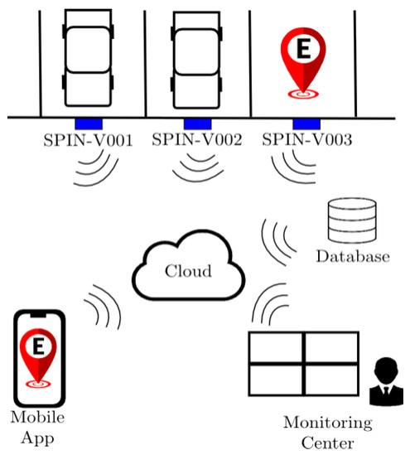PLATFORM DEVELOPMENT:

Developing a platform for a smart parking IoT solution involves integrating various components to create a cohesive system. Here's an overview of the development process:

1. **Sensor Network Setup:** Implement an IoT sensor network across the parking area. These sensors detect and transmit data on parking space occupancy.

2. **Data Collection and Processing:** Create a system to collect, process, and manage the data received from the sensors. This involves real-time analysis to determine parking space availability.

3. **Cloud Infrastructure:** Set up a robust cloud-based infrastructure to store and manage the collected data. Utilize scalable cloud services for efficient data processing and storage.

HARDWARE INTEGRATION:

Integrating hardware communication

1. **Sensor Selection:** Choose appropriate sensors (such as ultrasonic or magnetic sensors) capable of detecting parking space occupancy accurately.

2. **Connectivity:** Establish a reliable network infrastructure to connect the sensors to a central hub or gateway. This might involve Wi-Fi, Bluetooth, LoRa, or other connectivity protocols.

VERALL WORKFLOW:

Certainly, here's an overview of the workflow for integrating hardware into a smart parking IoT system:

♡ Requirements GatheringUnderstand: the project goals, the number of parking spaces to cover, and the desired features for the smart parking system.

♡ Sensor Selection and Procurement:Choose suitable sensors based on accuracy, connectivity, power requirements, and environmental adaptability.

CODE IMPLEMENTATION

Demonstrates the basic structure for handling sensor data, processing it, and providing a simple user interface to display parking space availability:

### Sensor Data Handling (Simulated for Illustration)

```python

class ParkingSensor:

def __init__(self, sensor_id):

self.sensor_id = sensor_id

self.is_occupied = False # Simulated occupied status

def check_status(self):

# Simulated method to check sensor status, can be replaced with actual sensor readings

# Example: Read sensor data using GPIO pins or sensor-specific libraries

# self.is_occupied = <logic to read sensor data>

pass

# Simulated sensors for four parking spaces

sensors = [ParkingSensor(1), ParkingSensor(2), ParkingSensor(3), ParkingSensor(4)]

def check_parking_status():

for sensor in sensors:

sensor.check_status()

# Processing the sensor data

available_spaces = sum(not sensor.is_occupied for sensor in sensors)

return available_spaces

```

### User Interface (Web Interface using Flask - Simplified Example)

```python

from flask import Flask, render_template

app = Flask(__name__)

# Route to display parking status

@app.route('/')

def parking_status():

available_spaces = check_parking_status()

return render_template('parking_status.html', available_spaces=available_spaces)

if __name__ == '__main__':

app.run(debug=True)

```

### HTML Template (parking_status.html)

```html

<!DOCTYPE html>

<html>

<head>

<title>Parking Status</title>

</head>

<body <h1>Parking Spaces Available: {{ available_spaces }}</h1>

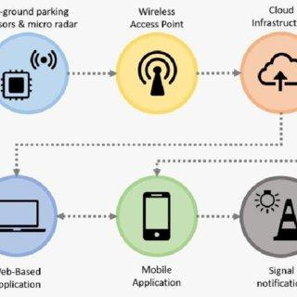

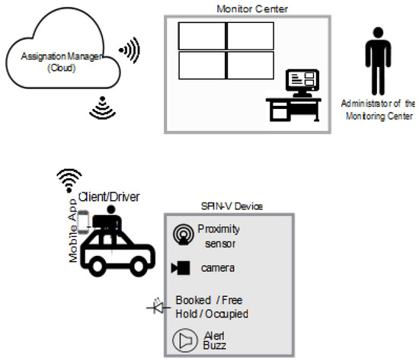 OUTPUT:

1. **Installation**: Ensure you have Python installed on your system. Additionally, install Flask by running `pip install Flask` in your terminal or command prompt.

2. **Create Files**: Create two files as mentioned earlier, `app.py` and `parking_status.html`, and place them in the same directory.

PROJECT EXPLANATION IN DETAIL:

1. Objective:

To create an intelligent parking system using IoT technology, allowing users to easily find available parking spaces and optimizing parking utilization.

2. Components:

Hardware:

Sensors: Ultrasonic or magnetic sensors installed in parking spaces to

- Software:

- Data Processing System:Code to interpret sensor data, process it, and determine parking space availability.

- User Interface (App/Website): An interface providing real-time parking space availability information to users.

- Backend System: Database and server for storing and managing data.

- **Connectivity:**- **Communication Protocol:** Establish protocols for data transmission between sensors and the central system.

- **Network Infrastructure:** Ensure a reliable network (Wi-Fi, Bluetooth, etc.) for sensor-to-gateway communication.

3. CONCLUSION:Phases:

Research and Planning:

- Understand user needs, existing parking challenges, and available technologies.

-Hardware Implementation:

- Select sensors, install them in parking spaces, and set up the central hardware unit for data processing.

-Software Development:

- Create code for sensor data

- Combine hardware and software components, ensuring seamless

●Hardware Implementation

●Software Development

●Connectivity

● Integration and Testing

● Deployment and Maintenance

CONCLUSION:

In conclusion, the implementation of a smart parking IoT system presents a promising solution to address the challenges associated with parking space management. By combining hardware components such as sensors and a central processing unit with sophisticated software solutions, this technology offers a range of benefits.